First Responders:

Trauma-Informed Systems Training

Online Trauma/Brain 101: Understanding the Impact of Trauma on Brain Development
Trauma/Brain Development 201: Building Resiliency
Recognizing & Managing Secondary Traumatic Stress

Trauma STARS

Connections Matter Georgia

CDC's Preventing Adverse Childhood Experiences

Adult Mental Health First Aid*

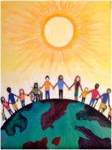
Community Resiliency Model
CIT: Crisis Intervention Training
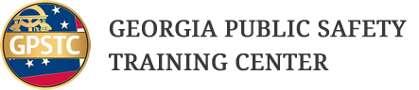
Compassion Integrity Training

Prevention Training
Cultural Humility Training
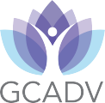
Handle With Care Plan
Human Trafficking Prevention

PCAGA's Mandated Reporter Training

QPR (Question, Persuade, Refer)
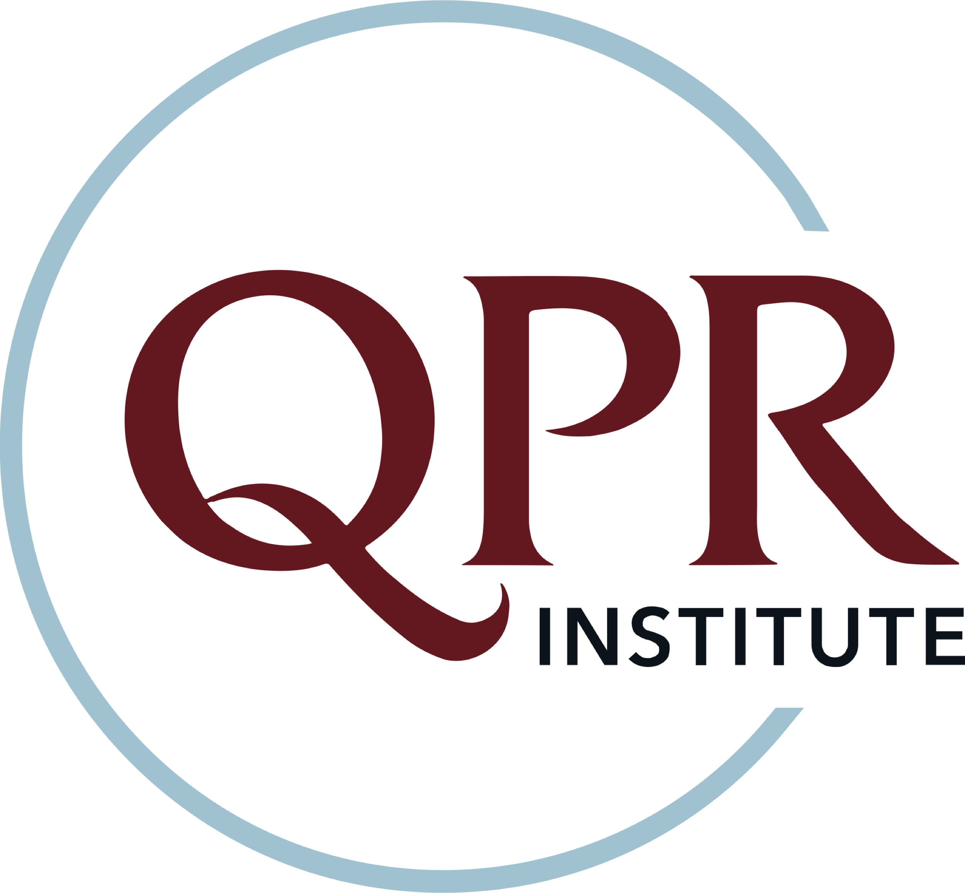
SafeTALK
Stewards of Children
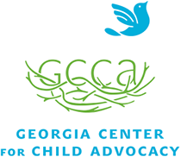

Strong for Life: Resiliency and Emotional Wellness

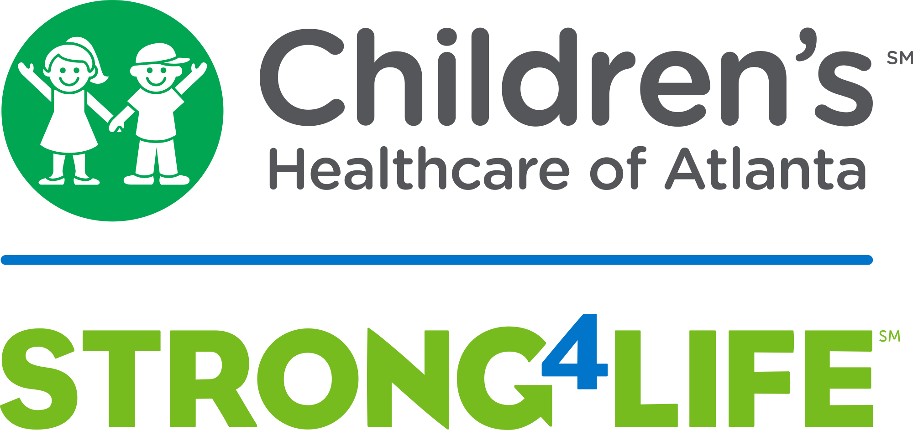

Psychological First Aid & Skills for Psychological Recovery
Compassion Integrity Training

Worksite Wellness Training

Recognizing & Managing Secondary Traumatic Stress
Total Worker Health
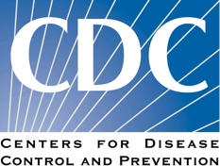
Community Resiliency Model
Compassion Integrity Training
Nurturing an Effective Workforce: Leadership Strategies and Considerations
Mindful Self-Compassion Training
Mindfulness/ Yoga

Peer Support

Compassion Fatigue 101: Online Course
Resilience in Trauma-Exposed Work Online Course

